PRINCIPAL
NAME OF FACULTY | DESIGNATION | QUALIFICATION | REG. NO | DOB | DATE OF  JOINING | EXPERIENCE |  |  | PHOTO
SAMHITA SIDDHANTA
PROF. (DR.) B. P. PATEL  STAFF QUARTER , MANDHANA KOTHI MPGI KANPUR 209217  Contact No. 8839594406  Email Id:- drbanshapatiprasad@gmail.com  Teachers Code (AYSS00984) | PRINCIPAL/  PROFESSOR | MD,  SAMHITA SIDDHANTA | 40719 | 14/07/1964 | 02/11/2023 | 10/05/2006-  TO  06/01/2009  07/01/2009  TO  09/05/2011  10/05/2011  TO  17/12/2013  18/12/2013  TO  09/05/2016  10/05/2016  TO  31/12/2019  25/01/2020  TO  06/05/2023  02/11/2023  TO  TILL DATE | ASSIATANT  PROFESSER  ASSIATANT  PROFESSER  ASSOCIATE  PROFESSER  ASSOCIATE  PROFESSER  PROFESSOR  PROFESSOR  PRINCIPAL/PROFESSOR | OM AYURVEDIC MEDICAL COLLEGE ,BETUL.MP  ASS MAHAVIDYALAYUA , CHITRKOOT M.P  ASS MAHAVIDYALAYUA , CHITRKOOT M.P  SRI SAI AYURVEDIC MEDICAL COLLEGE ,ALIGARH  SRI SAI AYURVEDIC MEDICAL COLLEGE ,ALIGARH  GOVERNMENT AYURVEDIC COLLEGE ATARRA BANDA UP  MAHARANA PRATAP AYURVEDIC MEDICAL COLLEGE &HOSPITAL BITHOOR KANPUR | 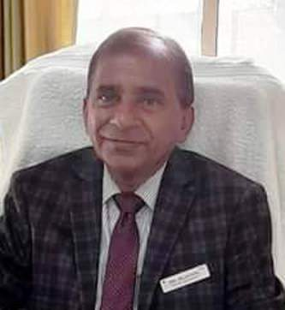

NAME OF FACULTY | DESIGNATION | QUALIFICATION | REG. NO | DOB | DATE OF  JOINING | EXPERIENCE |  |  |  | PHOTO
DR. ANAMIKA DAS  30, KALIBARI ROAD PANCHGRAM ASSAM 788802  Contact No. 6003633885  Email Id:- anamikadasapu.95@gmail.com  Teachers Code (AYSS01802) | ASSISTANT PROFESSOR | MD,  SAMHITA SIDDHANTA | 1377 | 26/12/1994 | 16/01/2025 | 16/03/2023  TO  22/06/2024  24/06/2024  TO  15/01/2025  16/01/2025  TO  TILL DATE | ASSISTANT PROFESSOR  ASSISTANT PROFESSOR  ASSISTANT PROFESSOR | sanjeevani ayurvedic medical college  shri babu jay jay singh ayurvedic medical college & hospital  MAHARANA  PRATAP AYURVEDIC MEDICAL COLLEGE & HOSPITAL  BITHOOR  KANPUR |  | 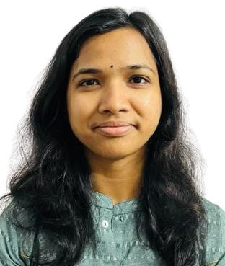
DR. AKHILESH KANTH SV  SK BHAvAN, KOTTARA  MEEYANNOOR, KOLLAM  KERALA-691537  Contact No. 8547162175  Email Id drakhileshkanth@gmail.com  Teachers Code:(AYSS02050) | ASSISTANT PROFESSOR | MD,  SAMHITA SIDDHANTA | 14665 | 22/07/1988 | 10/10/2025 | 13/05/2024 TO  09/10/2025  10/10/2025 TO  TILL DATE | ASSISTANT  PROFESSOR  ASSISTANT  PROFESSOR | IIMT AYURVEDIC MEDICAL COLLEGE & HOSPITAL MEERUT U.P  MAHARANA  PRATAP AYURVEDIC MEDICAL COLLEGE &HOSPITAL BITHOOR KANPUR |  | 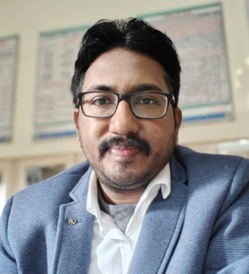
Dr. Preeti  Devi  71-A Vinayakpur Makdikheda Nawabganj, khyora katari, Kanpur Nagar, U.P-208002  Contact No. 9119814822  Email Id awasthipreeti059@gmail.com  Teachers Code:( (AYSN00667) | ASSISTANT PROFESSOR | M.A, Ph.D  Sanskrit | N/A | 15/07/1986 | 02/11/2023 | 02/11/2023  TO  TILL DATE | ASSISTANT PROFESSOR | MAHARANA PRATAP AYURVEDIC MEDICAL COLLEGE &HOSPITAL BITHOOR KANPUR |  | 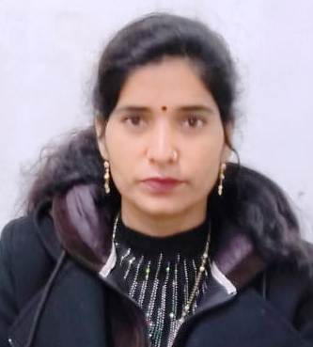
RACHANA SHARIR
dr. kamla yadav  4/236 VIJAYANT KHAND, GOMATINAGAR  LUCKNOW  Uttar Pradesh- 226010  CONTACT No. 9415681192  Mail Id:- kamalayadava@gmail.com  (AYRS00572) | Professor | md.  RACHANA SHARIR |  | 04/04/1960 |  | 01/Jan/2002  31/Dec/2006  01/Jan/2007  31/Oct/2010  03/Nov/2010  28/Jan/2019  28/Jan/2019  30/Jun/2020  05/Jul/2020  22/Feb/2021  22/Feb/2021  09/Nov/2023  10/Nov/2023  30/06/2025  28/01/2026  TO  TILL DATE | Assistant Professor  Assistant Professor  Assistant Professor  Assistant Professor  Assistant Professor  Professor  Professor  Professor | Aligarh Ayurvedic Medical College and ACN Hospital, Aligarh  Aligarh Ayurvedic Medical College and ACN Hospital, Aligarh  State Ayurved College  State Ayurved College  Sardar Patel Insitute of Ayuvedic Medical Science & Reseach Centre, Lucknow  Sardar Patel Insitute of Ayuvedic Medical Science & Reseach Centre, Lucknow  Babu Yugraj Singh Ayurvedic Medical College & Hospital, Baghamau, Lucknow,  MAHARANA PRATAP AYURVEDIC MEDICAL COLLEGE &HOSPITAL BITHOOR KANPUR |  | 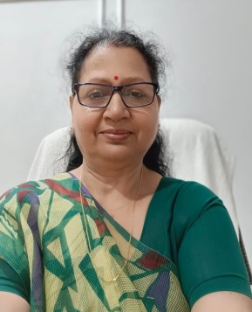
DR.PRIYANKA CHAUHAN  THAPLI CHAURAS KILKILESHWAR  TEHRIGARHWAL U.K  Contact No. 8979755321  Email Id  priyaankachauhan07@gmail.com Teachers Code (AYRS01474) | ASSISTANT PROFESSOR | md.  RACHANA SHARIR | UK-4516 | 03/07/1993 | 11/10/2025 | 01/03/2024 TO  31/05/2024  16/06/2024 TO  10/10/2025  11/10/2025  TO  TILL DATE | ASSISTANT PROFESSOR  ASSISTANT PROFESSOR  ASSISTANT PROFESSOR | MATOSHRI AASARABAI DARADE AYURVED COLLEGE AND HOSPITAL, BABHULGAON  SATYARAJ AYURVEDIC MEDICAL COLLEGE & HOSPITAL BAREILLY U.P  MAHARANA PRATAP AYURVEDIC MEDICAL COLLEGE &HOSPITAL BITHOOR KANPUR |  | 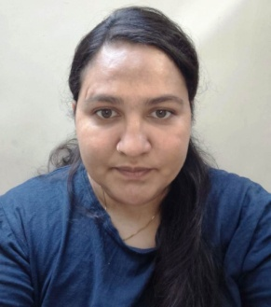
KRIYA SHARIR
DR. NITIN AWADHIYA  FORESH COLONY, GRAM – KURAI OST KURAI, SEONI, MAHDYA PRADESH- 480880  Contact No. 6261078189  Email Id  nitinawadhiya446@gmail.com  Teachers Code AYKS00857 | ASSOCIATE PROFESSOR | md  kRIYA sHARIRA | 55150 | 21/10/1986 | 23/12/2025 | 25/03/2021  TO 31/12/2022  02/01/2023 TO  18/12/2023  23/12/2025  to  26/03/2026  27/03/2026  to  till date | ASSISTANT  PROFESSOR  ASSISTANT  PROFESSOR  ASSISTANT  PROFESSOR  ASSOCIATE  PROFESSOR | Veena vadini ayurved college & hospital  Sardar Ajit Singh Smriti Ayurved Mahavidyalaya, Bhopal  MAHARANA PRATAP AYURVEDIC MEDICAL COLLEGE &HOSPITAL BITHOOR KANPUR  MAHARANA PRATAP AYURVEDIC MEDICAL COLLEGE &HOSPITAL BITHOOR KANPUR |  | 
DR. JAMUNA URANW  e-431 ward -44 near mangal bhavan kailash vihar 495450  Contact No. 8718979384  Email Id  jamuranw90@gmail.com  Teachers Code (ayks01030) | ASSISTANT PROFESSOR | md  kRIYA sHARIRA | CG04073AYU | 15/01/1990 | 01/07/2024 | 05/03/2022  to  25/03/2023  27/12/2023  to  30/06/2024  01/07/2024  to  till date | ASSISTANT PROFESSOR  ASSISTANT PROFESSOR  ASSISTANT PROFESSOR | shri santanpal singh ayurvedic medical colleges & hospital mirzapur tehsil jalalabad 242221  shri babu singh jay singh ayurvedic medical college & hospital  MAHARANA PRATAP AYURVEDIC MEDICAL COLLEGE &HOSPITAL BITHOOR KANPUR |  | 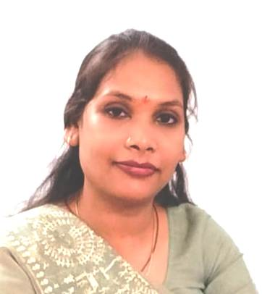
DRAVYAGUNA VIGYANA
DR.DHARMENDRA RAMAHOSHILA YADAV  VILLAGE BISUKIA POST BISUKIA DISTRICT BALLIA U.P 277503  Contact No. 6394295574  Email Id  me_dharmendrayadav@rediffmail.com  Teachers Code (AYDG01548) | ASSOCIATE PROFESSOR | md  DRAVYAGUNA VIGYANA | 65933 | 17/10/1987 | 22/07/2025 | 01/02/2021  TO  21/07/2025  22/07/2025  TO  31/01/2026  01/02/2026  TO  TIL DATE | ASSISTANT  PROFESSOR  ASSISTANT  PROFESSOR  ASSOCIATE  PROFESSOR | SHANTI AYURVEDIC MEDICAL COLLEGE & HOSPITAL BALLIA U.P  MAHARANA  PRATAP AYURVEDIC MEDICAL COLLEGE & HOSPITAL  BITHOOR  KANPUR  MAHARANA  PRATAP AYURVEDIC MEDICAL COLLEGE & HOSPITAL  BITHOOR  KANPUR |  | 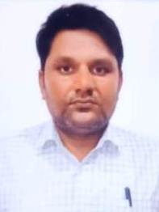
DR.MAMTA OJHA  plot no 197 panchawati vinayakpur kanpur nagar 208025  Contact No. 9084363087  Email Id  ojhamamta1788@gmail.com  Teachers Code (AYDG01827) | ASSISTANT PROFESSOR | md  DRAVYAGUNA VIGYANA | 60476 | 10/06/1988 | 23/09/2024 | 14/08/2023  to  21/09/2024  23/09/2024  to  till date | assistant  professor  assistant  professor | dhanvantri ayurvedic medical college & hospital  MAHARANA  PRATAP AYURVEDIC MEDICAL COLLEGE &HOSPITAL BITHOOR KANPUR |  | 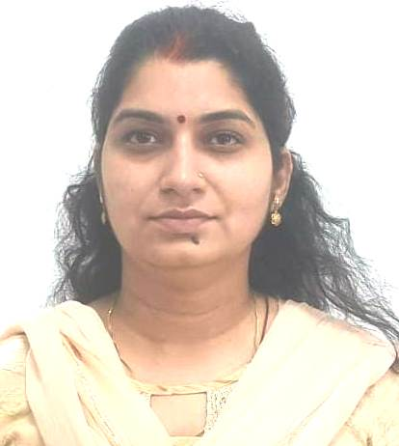
RASASHASTRA EVAM BHAISHJYA KALPANA
DR.SUMIT KUMAR  (AYRB01611)  GARAHAWAKALA BARAWAN KARCHANA PRAYAGRAJ 212301  PRAYAGRAJ U.P  Contact No. 9452241812  Email Id  sk.pandy9452241812@gmail.com  Teachers Code (AYRB01611) | ASSOCIATE PROFESSOR | md  RASASHASTRA EVAM BHAISHJYA KALPANA | 65419 | 25/01/1984 | 22/08/2025 | 16/09/2020  TO  17/01/2022  18/01/2022  TO  21/08/2025  22/08/2025  TO  15/09/2025  16/09/2025  to  till date | ASSISTANT  PROFESSOR  ASSISTANT  PROFESSOR  ASSISTANT  PROFESSOR  associate  PROFESSOR |  | DR.VIJAY AYURVEDIC MEDICAL COLLEGE & HOSPITAL VANARASI U.P  JEEVAK AYURVEDIC MEDICAL COLLEGE & HOSPITAL RESEARCH CENTER CHANDAULI U.P  MAHARANA  PRATAP AYURVEDIC MEDICAL COLLEGE & HOSPITAL  BITHOOR  KANPUR  MAHARANA  PRATAP AYURVEDIC MEDICAL COLLEGE & HOSPITAL  BITHOOR  KANPUR | 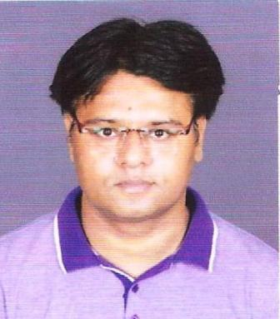
DR.RAHUL SHARMA  H/NO-R/14, 3RD PHASE, RAMA LITE CITY ,SAKRI ROAD, USLAPUR, BILASPUR , (C.G)PRAYAGRAJ U.P KERALA  Contact No 8847208760  Email Id  drrahulsharmaayu@gmail.com  Teachers Code AYRB01690) | ASSISTANT PROFESSOR | md  RASASHASTRA EVAM BHAISHJYA KALPANA | CG00831 | 14/07/1982 | 14/02/2025 | 11/01/2022 TO  28/02/2022  01/07/2022 TO  13/05/2025  14/02/2025  TO  TILL DATE | ASSISTANT  PROFESSOR  ASSISTANT  PROFESSOR  ASSISTANT PROFESSOR |  | BHARAT AYURVEDIC MEDICAL COLLEGE AND HOSPITAL,  KUNWAR SHEKAR VIJENDRA AYURVED MEDICAL COLLEGE & RESEARCH CENTER  MAHARANA  PRATAP AYURVEDIC MEDICAL COLLEGE & HOSPITAL  BITHOOR  KANPUR | 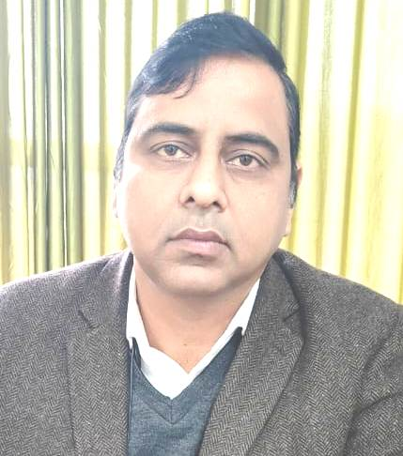
ROG NIDAN
DR.ABHAY PRATAP BHARTIYA  ingohata uttar pradesh hamirpur  Contact No 9755794843  Email Id:- drabhaychitrakoot@gmail.com  Teachers Code ayrn00780 | ASSOCIATE PROFESSOR | md  rog nidan | 50375 | 01/07/1976 | 01/08/2024 | 04/09/2020  to  05/08/2023  21/08/2023  to  31/07/2024  01/08/2024  to  19/09/2025  20/09/2025  TO  TILL DATE | ASSISTANT PROFESSOR  ASSISTANT PROFESSOR  ASSISTANT PROFESSOR  ASSOCIATE PROFESSOR |  | ankrite ayturvedic medical college and hospital  vimla family ayurvedic medical college & hospital  MAHARANA PRATAP AYURVEDIC MEDICAL COLLEGE &HOSPITAL BITHOOR KANPUR  MAHARANA PRATAP AYURVEDIC MEDICAL COLLEGE &HOSPITAL BITHOOR KANPUR | 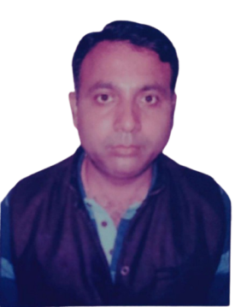
DR.AMRUTHA R KULKARNI  34, hema ganga residence lay out opposite gangamma thimmaya choultry nelamangala bengaluru karnataka 562123  Teachers Code (AYRN01069)  Email Id  amrutha.kulkarni.92@gmail.com  Contact No 8884910407 | ASSISTANT PROFESSOR | MD  rog nidan | 38574 | 02/04/1992 | 01/07/02025 | 19/12/2022  TO 27/09/2023  29/09/2023  TO  30/06/2025  01/07/02025  TO  TILL DATE | ASSISTANT PROFESSOR  ASSISTANT PROFESSOR  ASSISTANT PROFESSOR |  | INDIAN INSTITUTE OF AYURVEDIC MEDICINE & RESEARCH  SRI PARIPURNA SANATHANA AYURVEDA MEDICAL COLLEGE HOSPITAL & RESEARCH CENTER  MAHARANA  PRATAP AYURVEDIC MEDICAL COLLEGE & HOSPITAL  BITHOOR  KANPUR | 
AGAD TANTRA EVAM VIDHI
DR.RAMESH TRIPATHI  56, MIG AWAS VIKAS COLONY FATEHPUR UTTAR PRADESH- 212601  Contact No 7905140003  Email id:  tripathiramesh02@gmail.com  Teachers Code (AYAT00292) | ASSOCIATE  PROFESSOR | AGAD TANTRA EVAM VIDHI | 58082 | 02/07/1979 | 21/11/2025 | 18/09/2017  TO  31/12/2022  01/02/2023  TO  01/02/2023  02/02/2023  TO  31/11/2024  05/12/2024  TO  15/05/2025  21/11/2025  TO  TILL DATE | ASSISTANT  PROFESSOR  ASSISTANT  PROFESSOR  ASSOCIATE  PROFESSOR  ASSOCIATE  PROFESSOR  ASSOCIATE  PROFESSOR |  | INSTITUTE OF AYUSH MEDICAL SCIENCES, LUCKNOW  SHRI RAM CHANDRA VAIDYA AYURVEDIC MEDICAL COLLEGE AND HOSPITAL, LUCKNOW  SHRI RAM CHANDRA VAIDYA AYURVEDIC MEDICAL COLLEGE AND HOSPITAL, LUCKNOW  SHRI RAM CHANDRA VAIDYA AYURVEDIC MEDICAL COLLEGE AND HOSPITAL, LUCKNOW  MAHARANA PRATAP AYURVEDIC MEDICAL COLLEGE & HOSPITAL  BITHOOR  KANPUR | 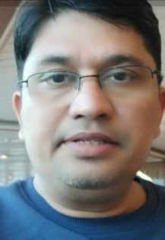
DR.PRIYANKA YADAV  168 MIG RATANPUR COLONY PANKI KANPUR NAGAR UTTAR PRADESH - 208020  Contact No 7054297964  Email Id  priyanka.yad92@gmail.com  Teachers Code AYAT00548 | ASSISTANT  PROFESSOR | AGAD TANTRA EVAM VIDHI | 60937 | 09/03/1992 | 19/09/2024 | 19/07/2021  to  03/01/2023  04/01/2023  to  18/09/2024  19/09/2024  to  till date | ASSISTANT PROFESSOR  ASSISTANT PROFESSOR  ASSISTANT PROFESSOR |  | dr.anar singh ayurvedic medical college & hospital  institute of ayush medical sciences  MAHARANA  PRATAP AYURVEDIC MEDICAL COLLEGE & HOSPITAL  BITHOOR  KANPUR | 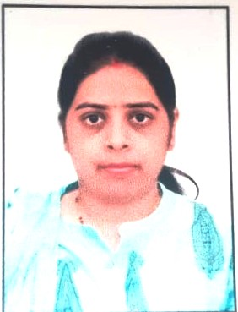
SWASTHAVRITTA EVAM YOGA
DR.ANJALI SINGH  133,ITMASITPURA NAGOD MADHYA PRADESH SATNA 485446  Teachers Code (AYSV00972)  Contact No 9452722282  Email Id  dranjali811@gmail.com | ASSISTANT  PROFESSOR | SWASTHAVRITTA EVAM YOGA | 55587 | 08/11/1990 | 02/12/2024 | 02/01/2023  TO  30/11/2024  02/12/2024  TO  TILL DATE | ASSISTANT PROFESSOR  ASSISTANT PROFESSOR |  | VEENAVADINI AYURVEDIC COLLEGE & HOSPITAL  MAHARANA  PRATAP AYURVEDIC MEDICAL COLLEGE & HOSPITAL  BITHOOR  KANPUR | 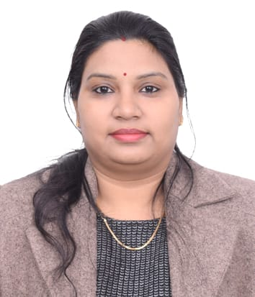
DR.MAMTA DWIVEDI  128/35f block kidwai nagar kanpur up 208011  EMail Id:  mamtadwivedi.dsvv@gmail.com  Contact No. 9695661120 | YOGa teacher | SWASTHAVRITTA EVAM YOGA | N/A | 10/05/1980 | 02/12/2024 | 02/12/2024  TO  TILL DATE | YOGa teacher |  | MAHARANA PRATAP AYURVEDIC MEDICAL COLLEGE &HOSPITAL BITHOOR KANPUR | 