Programme : PANCHAKARMA REFRESHER TRAINING PROGRAMME.
Venue : Maharana Pratap Ayurvedic Medical College Hospital.
Cordinators : Dr Sandeep Jain (MD ) Panchakarma
: Dr Manish Singh (Medical Superintendent)
: Dr Mamta Dvivedi (Yoga instructor)
Event Date : 9nth April 2026 - 17nth April 2026
Inauguration DAY 1 - 9th April 2026
Participants : 80
The inaugural session of the Panchakarma Refresher Training Programme for Government Ayurvedic Medical Officers was successfully conducted at Maharana Pratap Ayurvedic Medical College & Hospital, Bithoor Campus. The programme aimed at upgrading the clinical and practical knowledge of Panchakarma therapies among participating medical officers.
The programme commenced with a warm welcome of the Chief Guest Dr Kaptan Singh (Kshetriya Ayurveda & Unani Jilla Adhikari)and Dr Nirankar Goel( Retired Kshetriya Ayurveda & Unani Officer) and inaugural ceremony was conducted in the esteemed presence of Dr Alok Mishra (Director, Maharana Pratap Ayurvedic Medical College ),Dr B. P Patel (Principal, Maharana Pratap Ayurvedic Medical College), Dr Manish Singh (Medical Superintendent) and distinguished Government medical officers, faculty members, and all students. The welcoming ceremony created an atmosphere of enthusiasm and academic spirit, setting a positive tone for the entire training programme.
During the inaugural session, esteemed guests shared their valuable insights on the relevance and growing importance of Panchakarma in present-day clinical practice. Their addresses प्रेरित (inspired) the participants to actively engage in learning and apply the knowledge effectively in their respective healthcare settings.
Director, Dr. Alok Mishra, in his address, highlighted the necessity of continuous skill enhancement and emphasized the role of such refresher programmes in strengthening Ayurvedic healthcare delivery systems.
Principal, Prof. Dr. B. P. Patel, delivered an insightful speech focusing on the academic and practical integration of Panchakarma procedures.
The programme was effectively coordinated under the guidance of Medical Superintendent Dr. Manish Singh (Dept. of Salya Tantra) and Dr. Sandeep Jain (Dept. of Panchakarma) whose efforts ensured smooth organization and execution of the inaugural event as well as subsequent training activities.
Following the inaugural session, the academic schedule proceeded with demonstrations and practical sessions of Panchakarma procedures, ensuring active participation of all delegates.

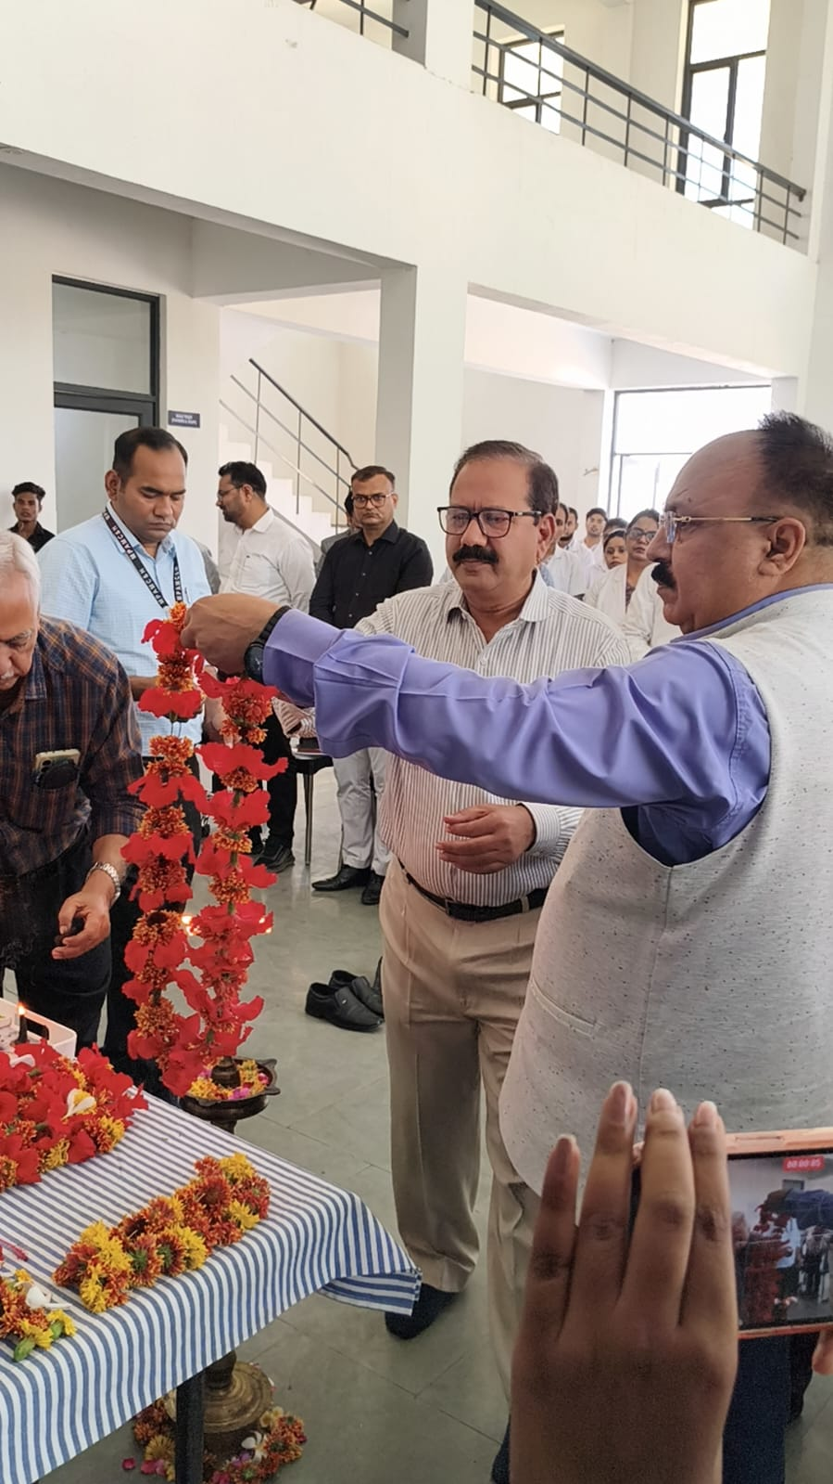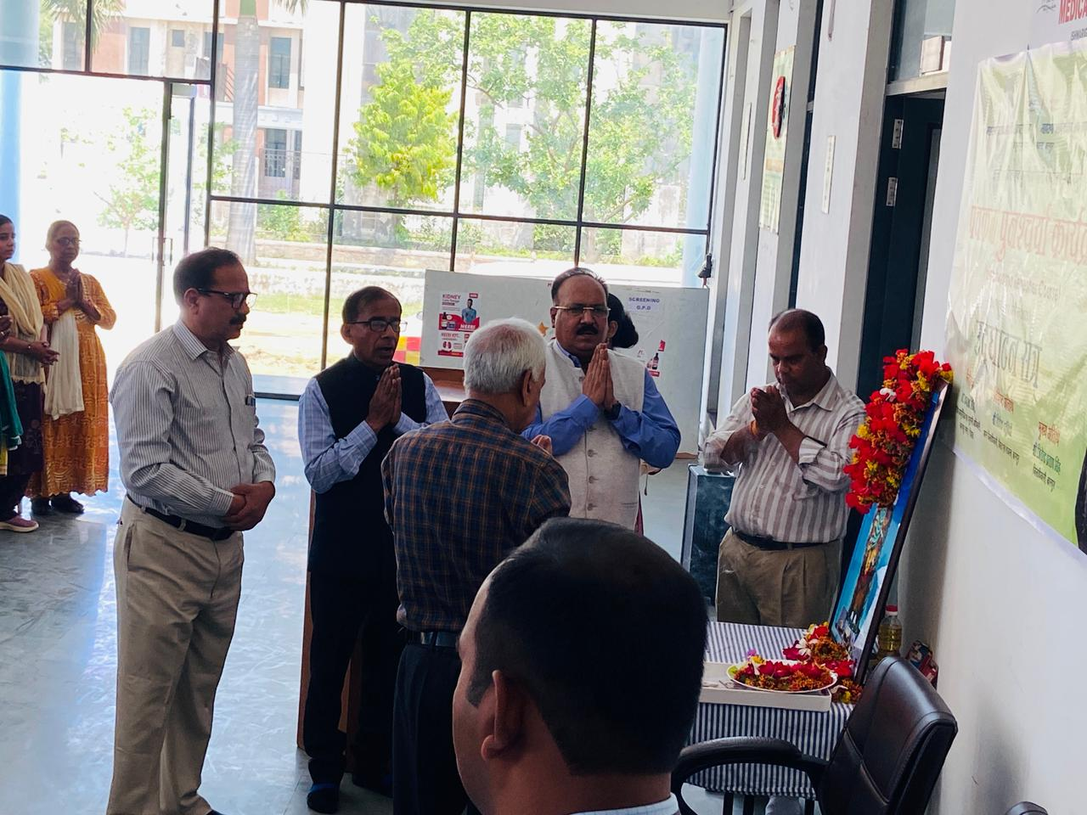
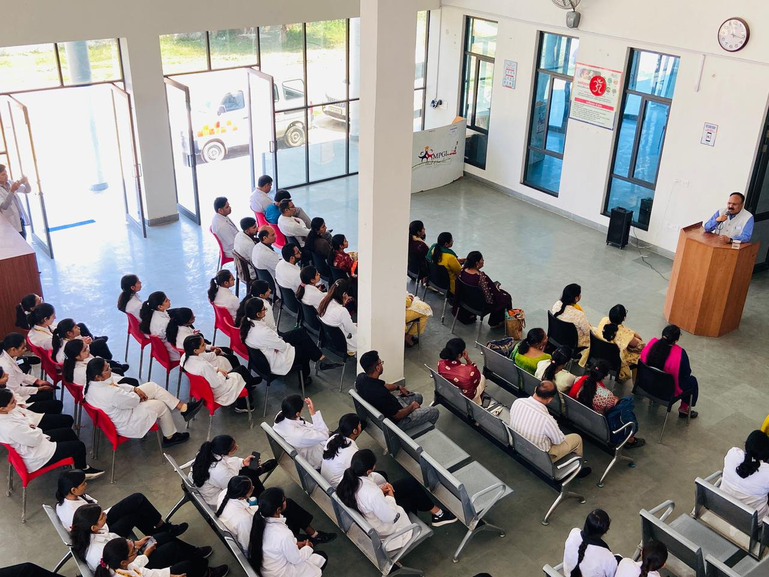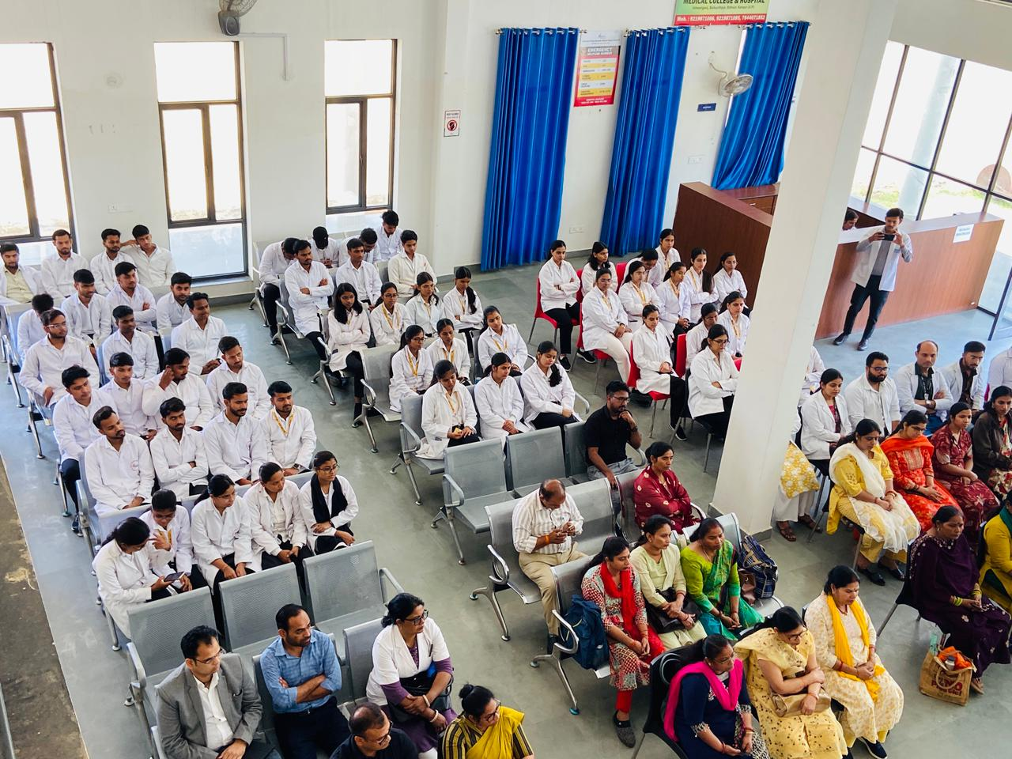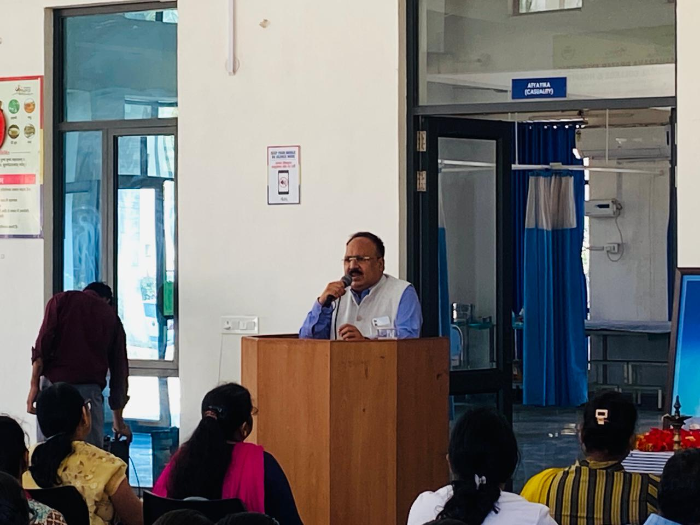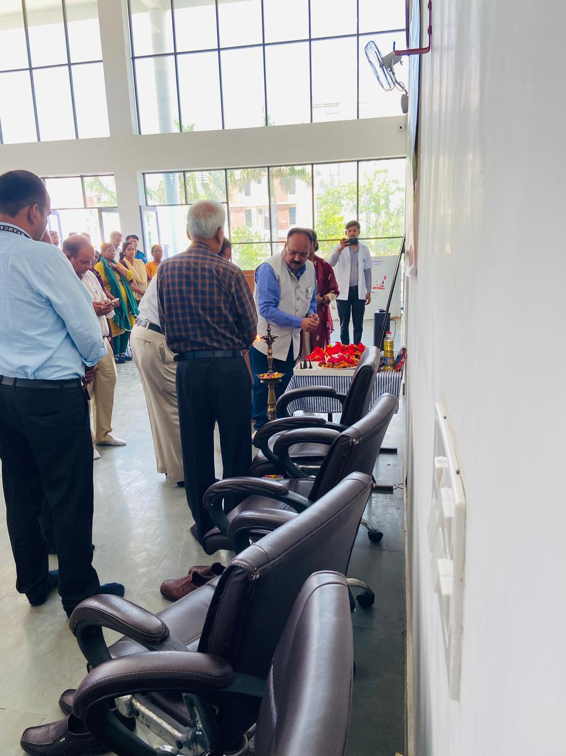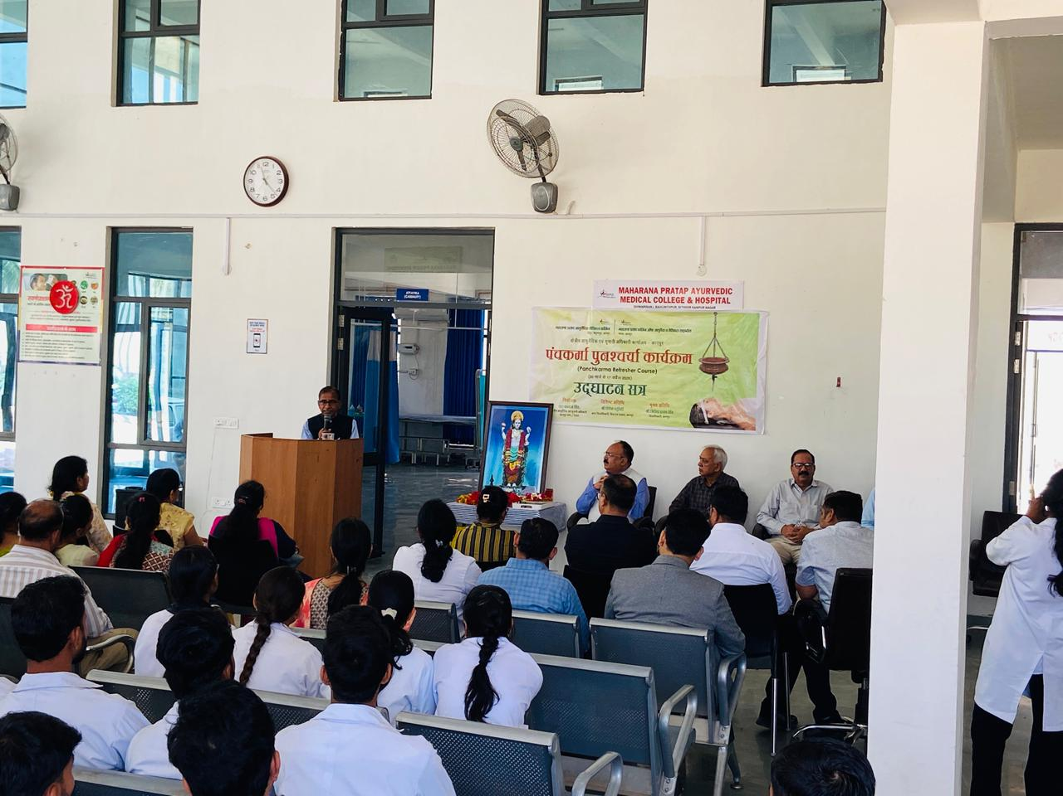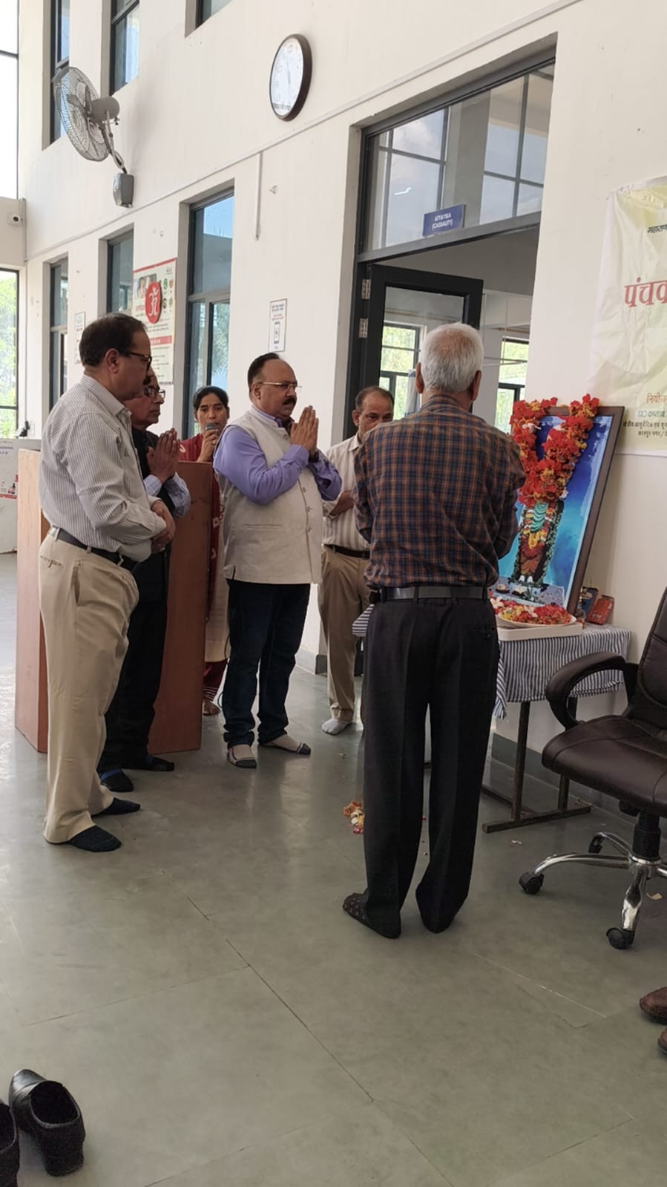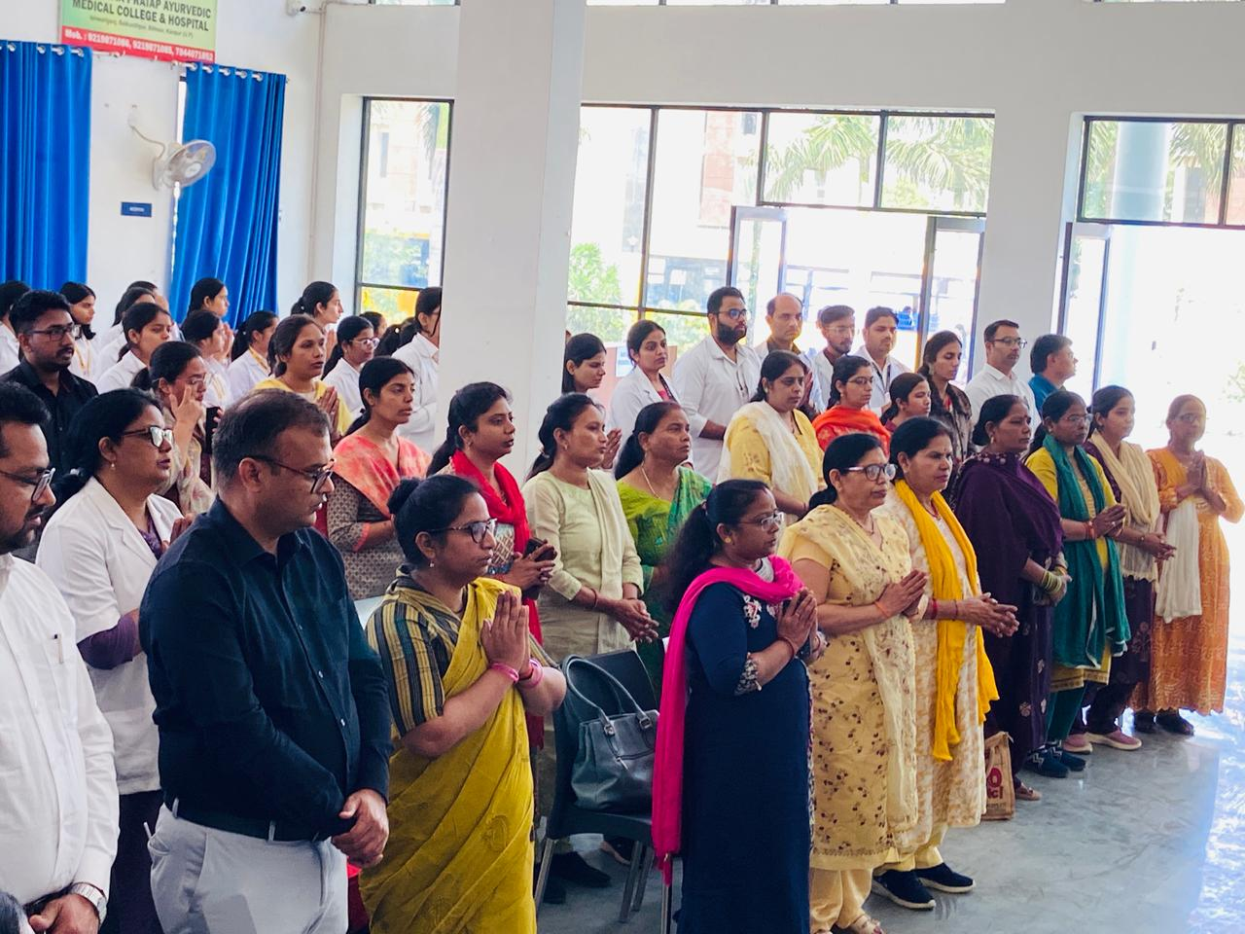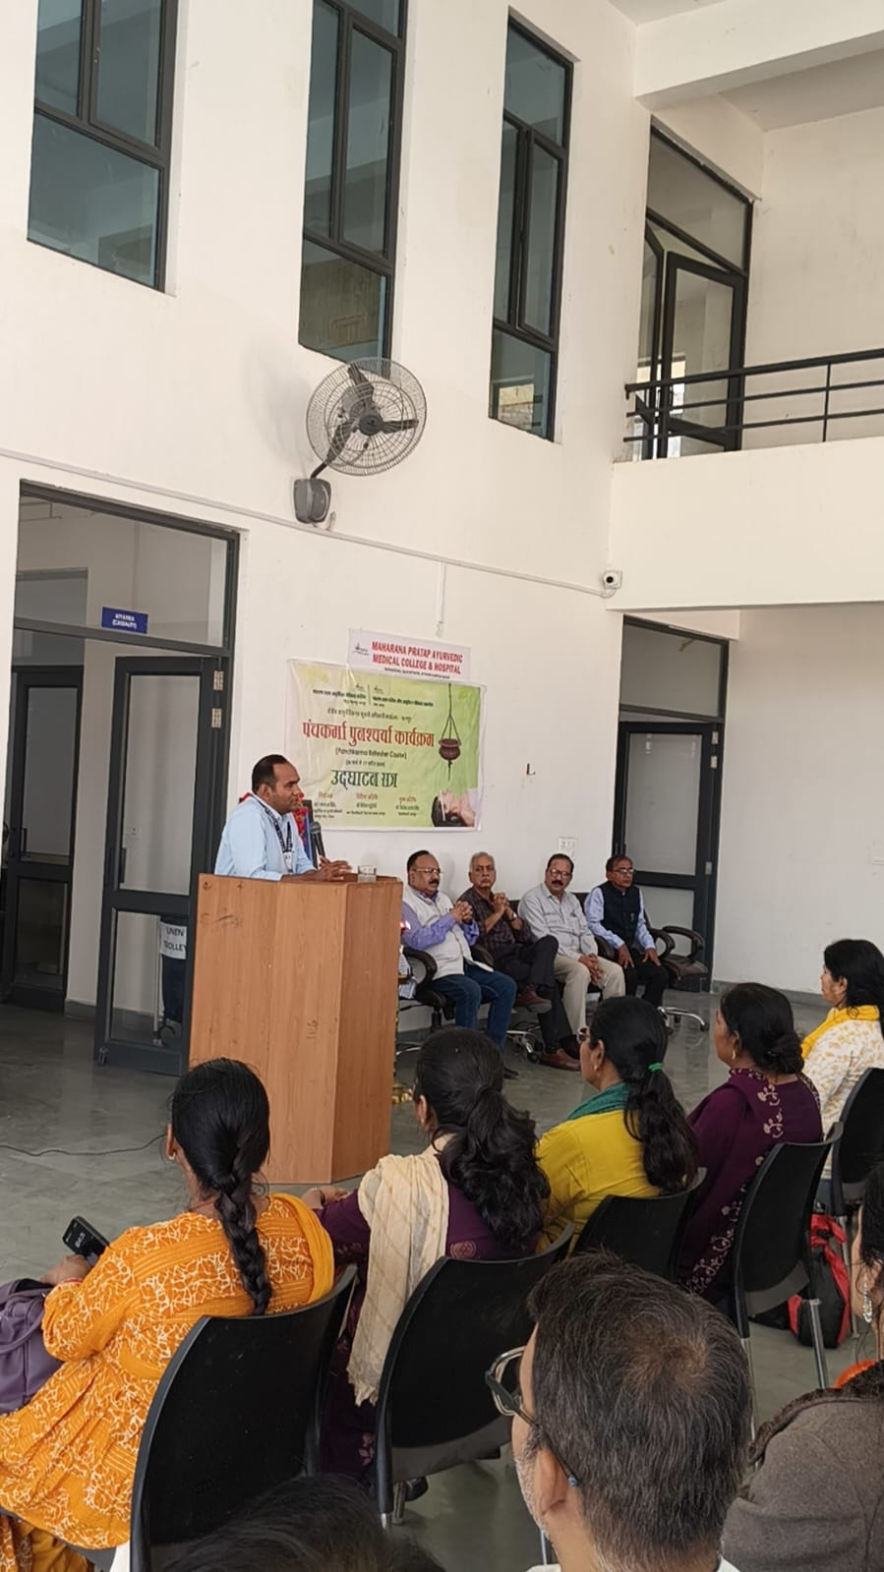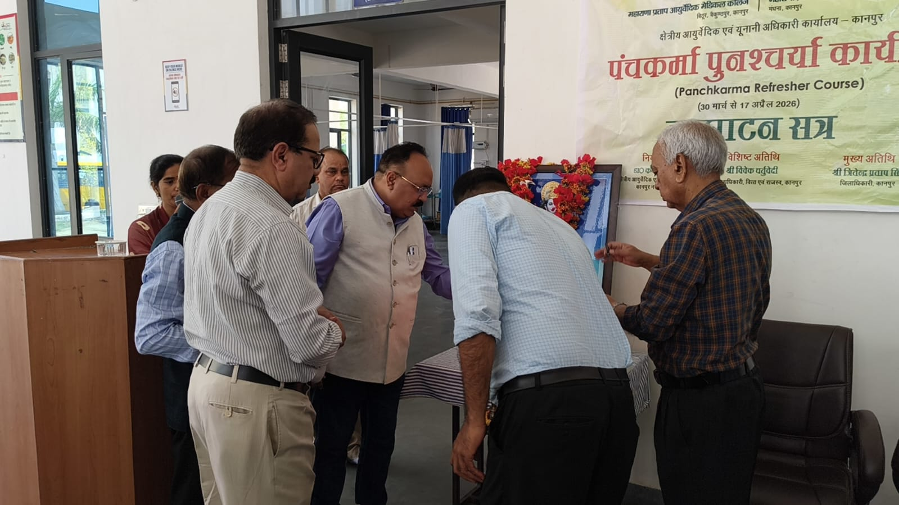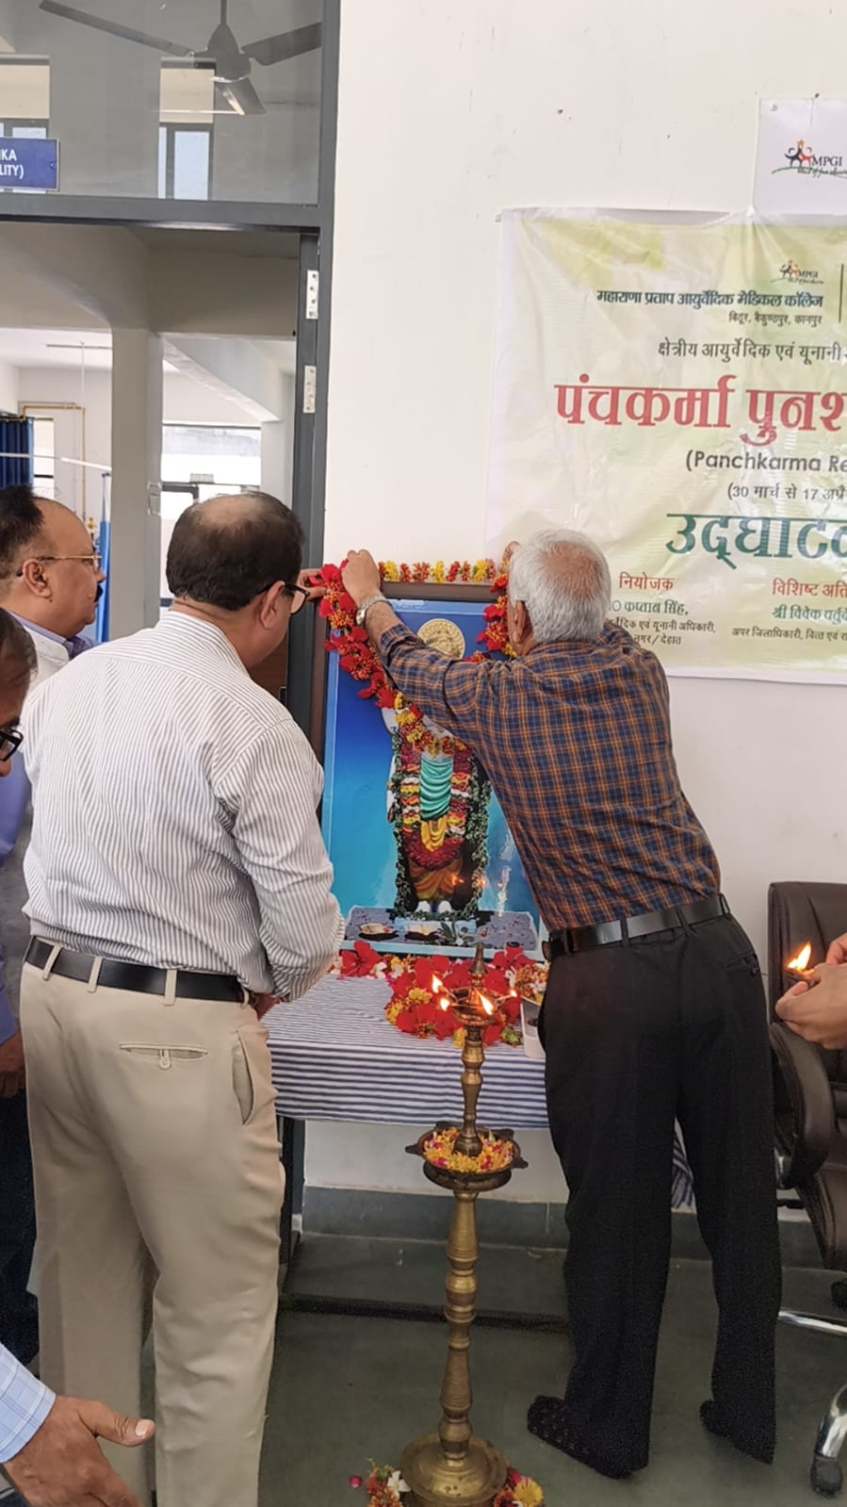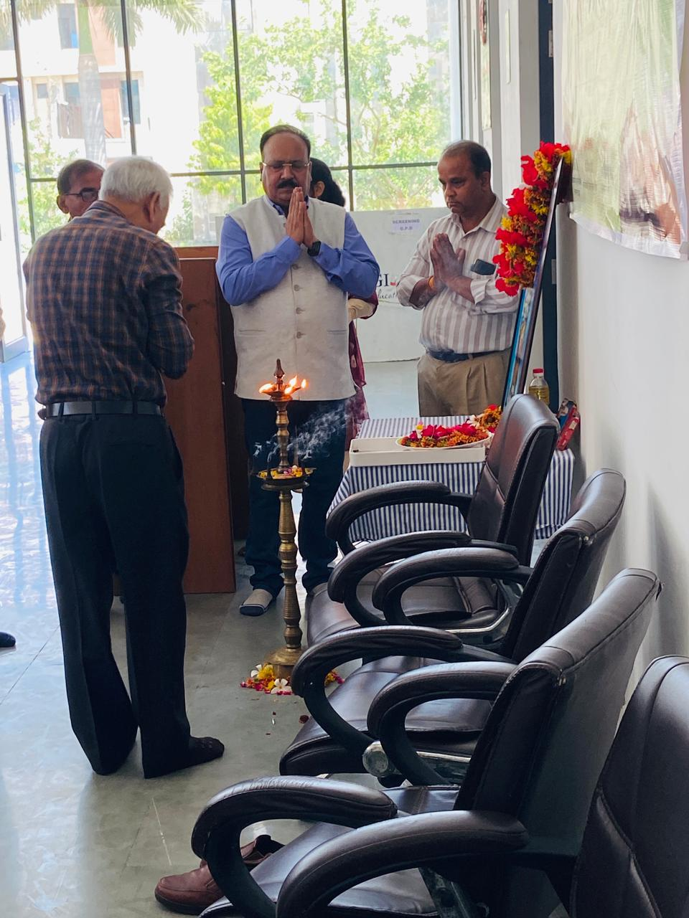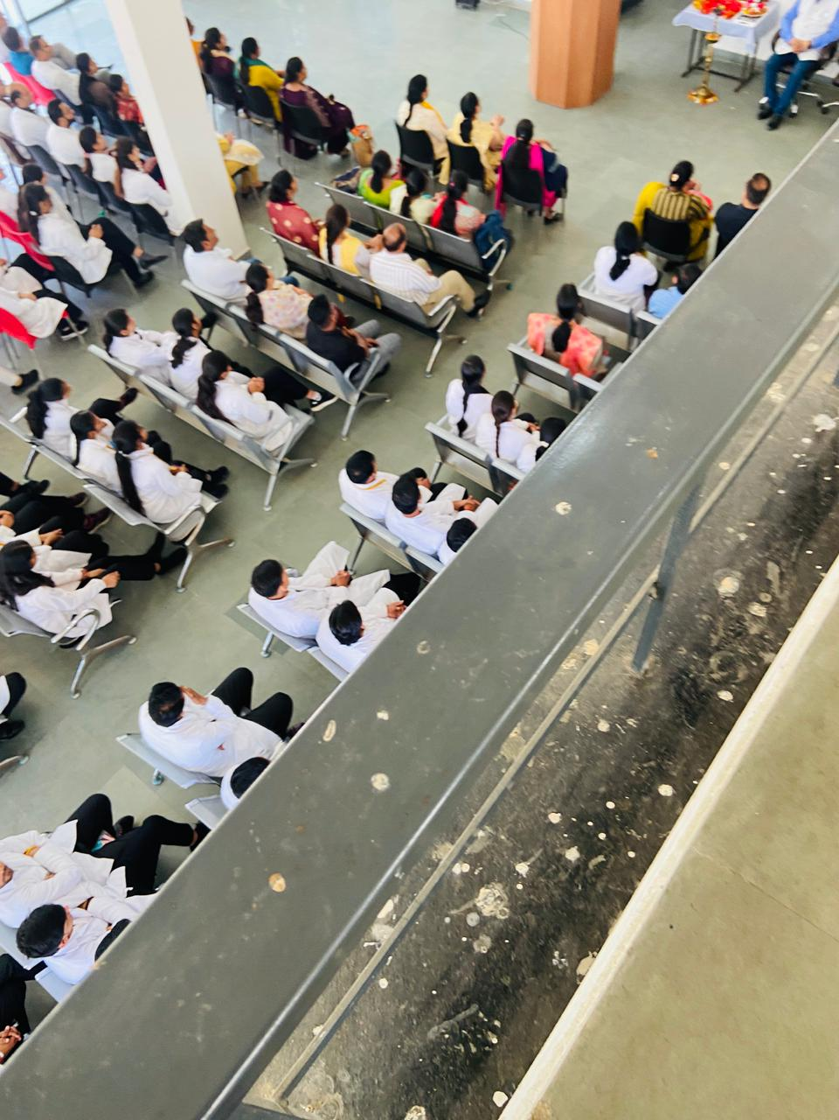

Day 2 (10 April 2026)
The second day started with Yoga session & Meditation under the guidance of Dr Mamta Dvivedi. Next session emphasized Sarvanga Abhyanga under the guidance of Dr Sandeep Jain demonstrating proper techniques and therapeutic benefits. Later, a detailed live demonstration of Nasya Karma was conducted. Participants actively engaged in discussions and practical sessions to reinforce learning.
Day 3 (11 April 2026)
Day started with yoga & meditation.The focus of the day was on Niruha Basti, including preparation, administration, and clinical indications. The post-break session covered Lepa.
---
Day 4 (13 April 2026)
Day started with meditation & yoga sessions including Suryanamaskara, Vajrasana, shalabh asana etc. Participants were trained in Kriya Kalpa, particularly ocular therapeutic procedures. The second session included Marma Therapy, explaining vital points.
---

Day 5 (15 April 2026)
Day started with meditation & yoga sessions.This day covered Shastika Shali Pinda Sweda and Patra Pinda Sweda, focusing on preparation and therapeutic use. The later session demonstrated Raktamokshana, highlighting its role in bloodletting therapies. Interactive discussions supported deeper clinical insight.
---
Day 6 (16 April 2026)
Day started with meditation & Yoga sessions. The sessions included Bal Panchakarma, addressing pediatric considerations in Panchakarma therapies. This was followed by demonstrations of Shirodhara and Shiropichu, explaining their benefits in neurological and stress-related conditions.
---
Day 7 (17 April 2026)
On Final day meditation procedures, Pranayama, Bhastrika kriyakarma, Ohm chanting & prayer sessions were held.
The final day focused on Sthanic Chikitsa (local treatments) and Saundarya Chikitsa (cosmetic Ayurveda). These sessions highlighted practical approaches for localized disorders and aesthetic care using Ayurvedic principles. The programme concluded with discussions and participant practice.
YOGA SESSIONS
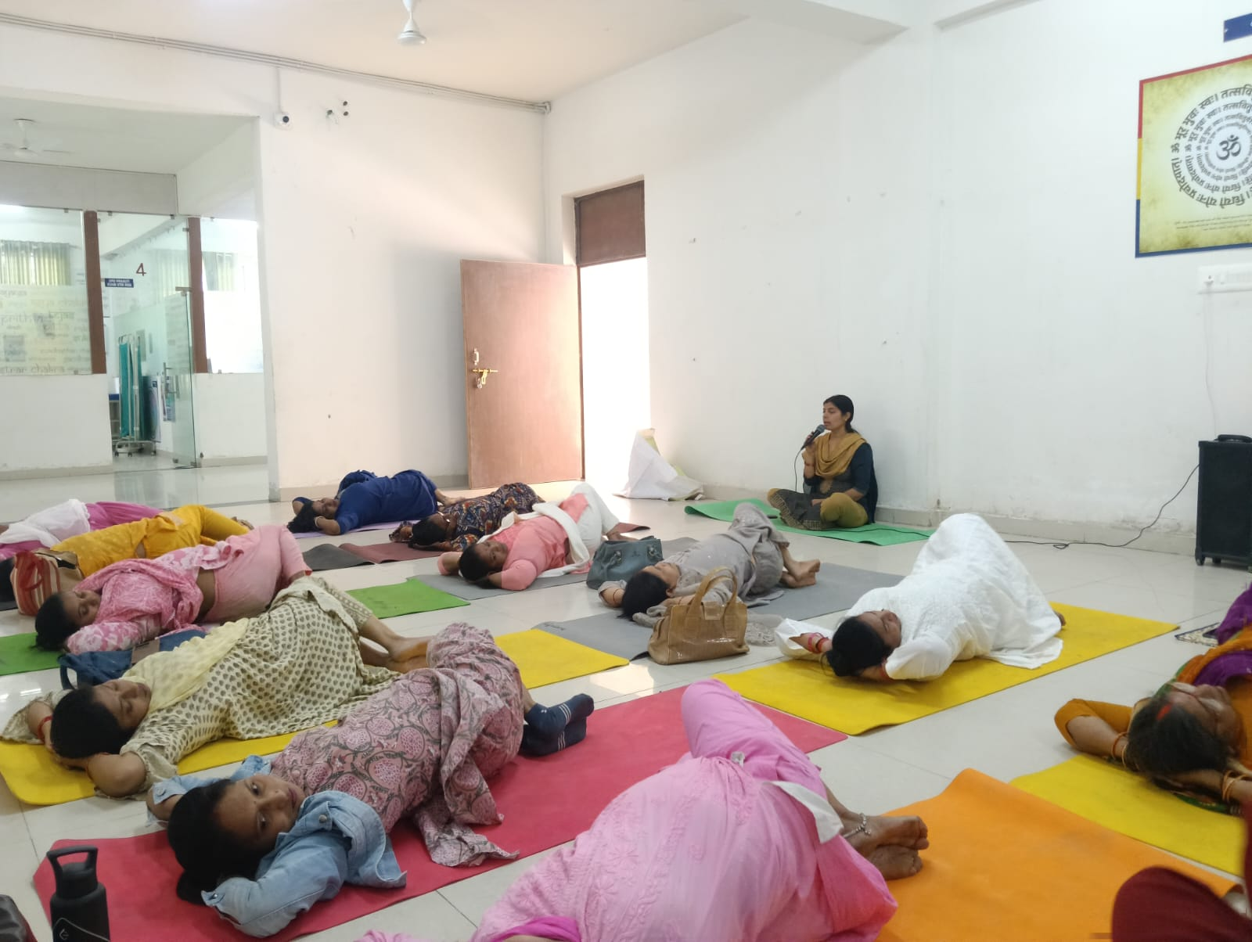
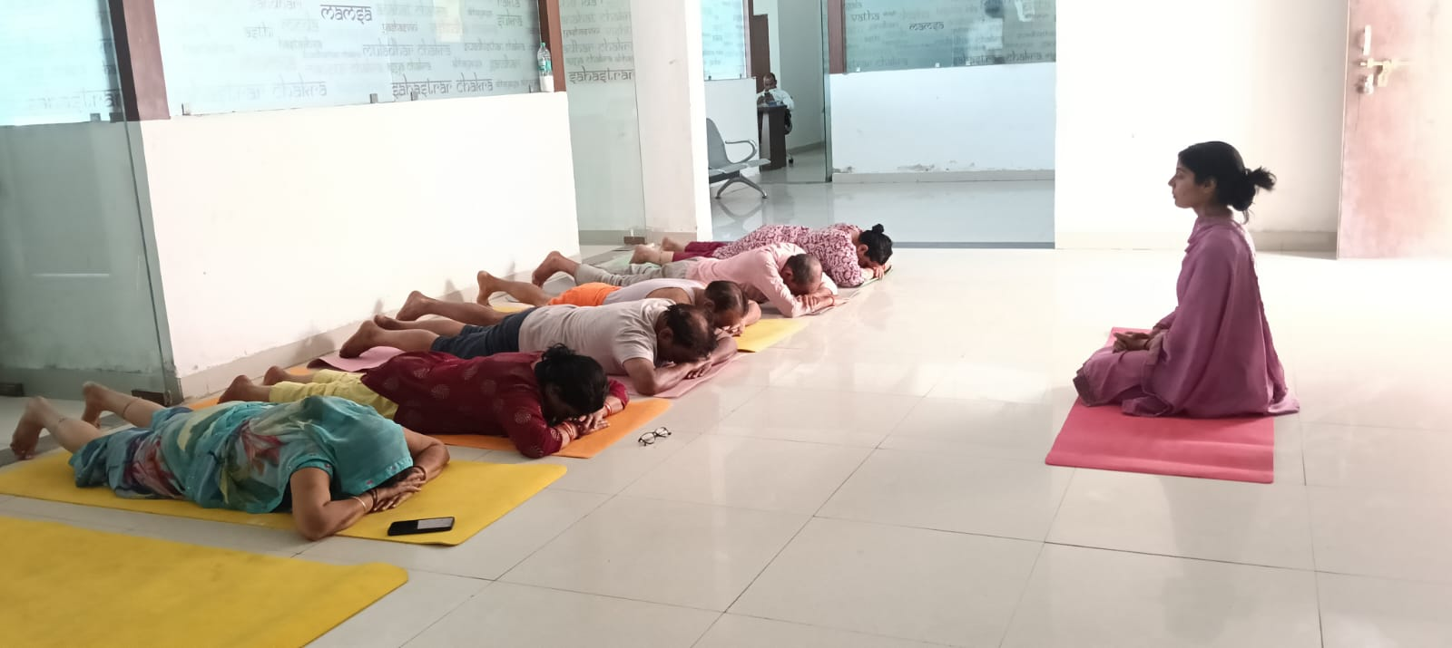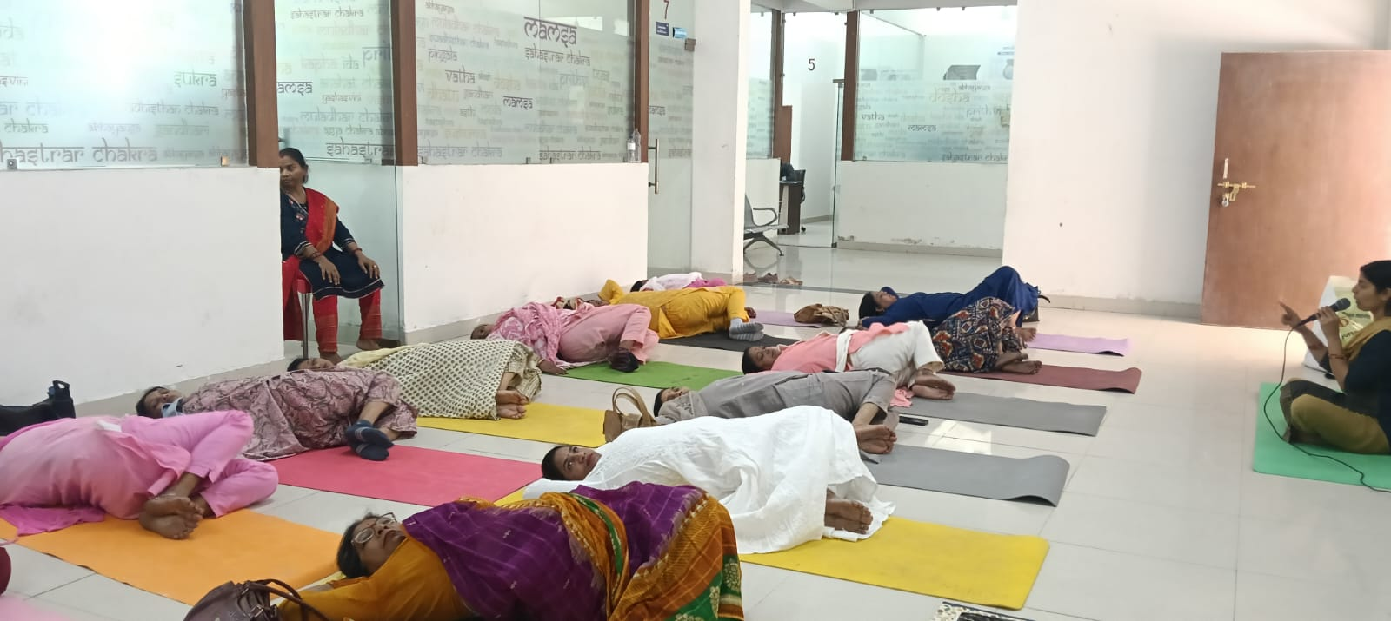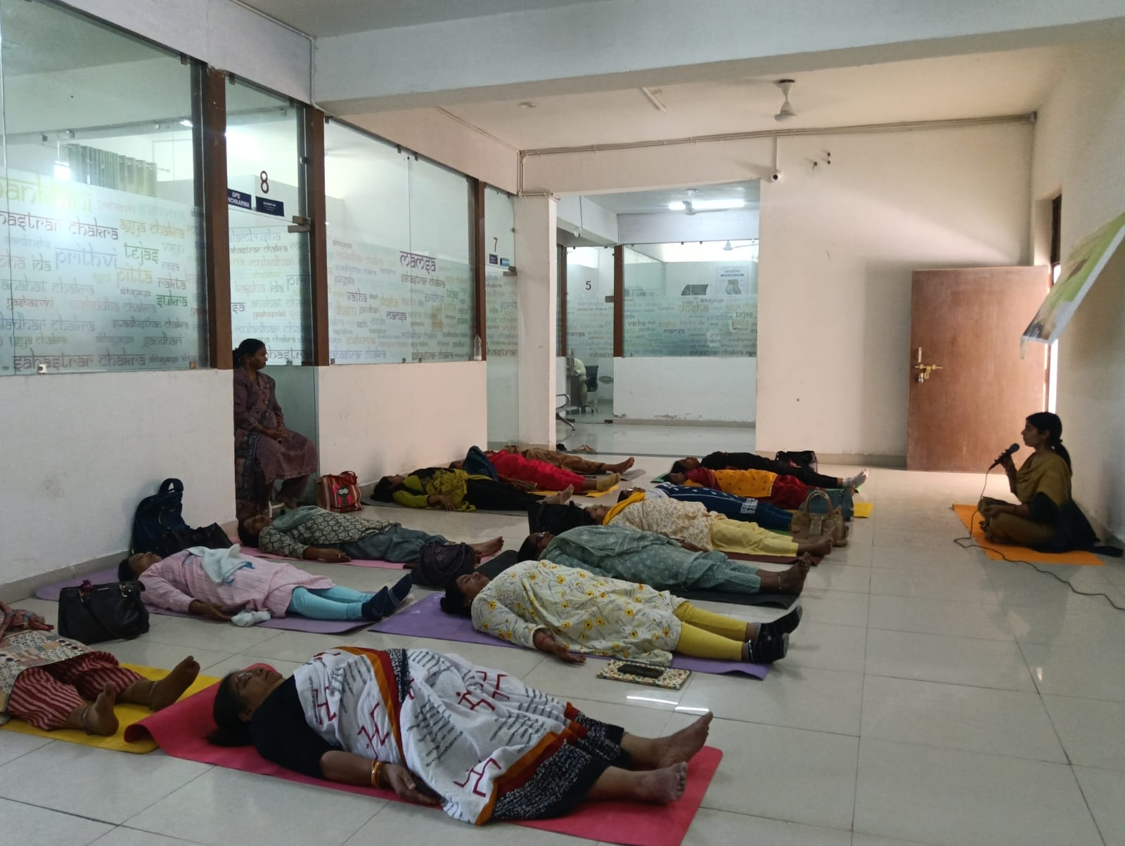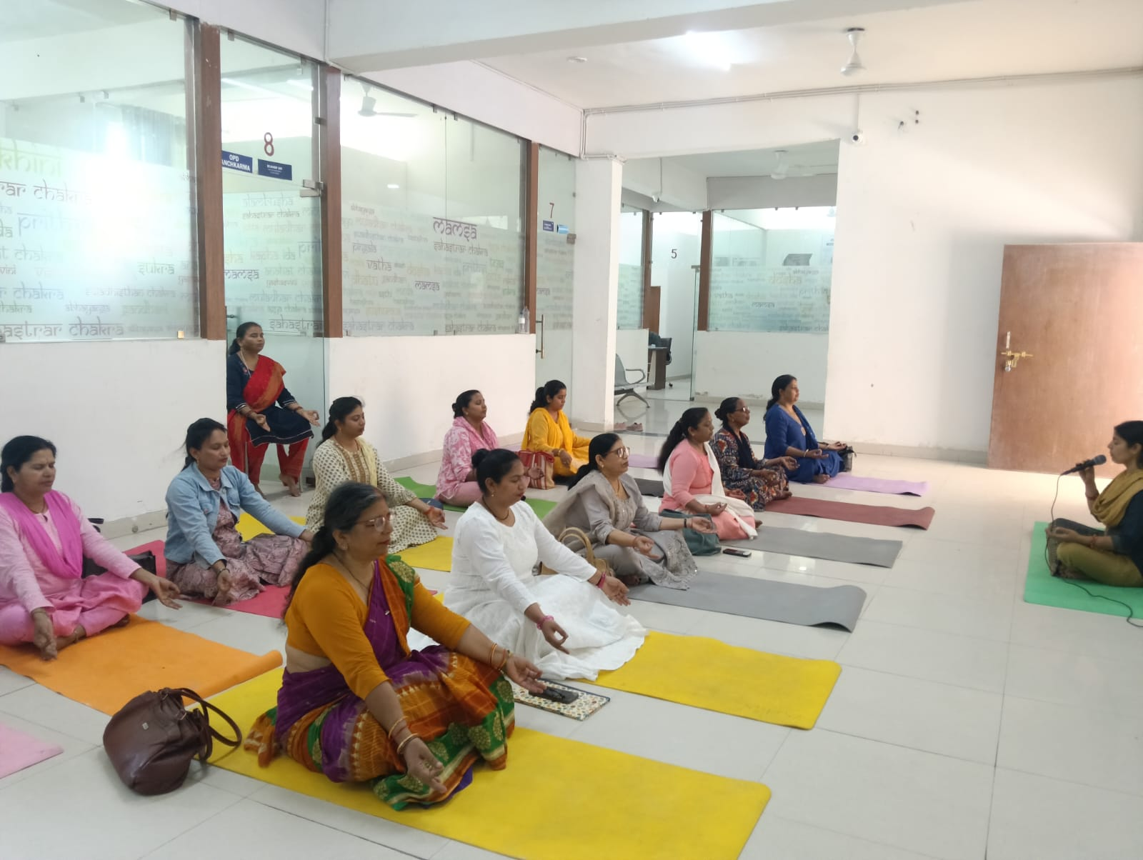
---

PANCHAKARMA SESSIONS
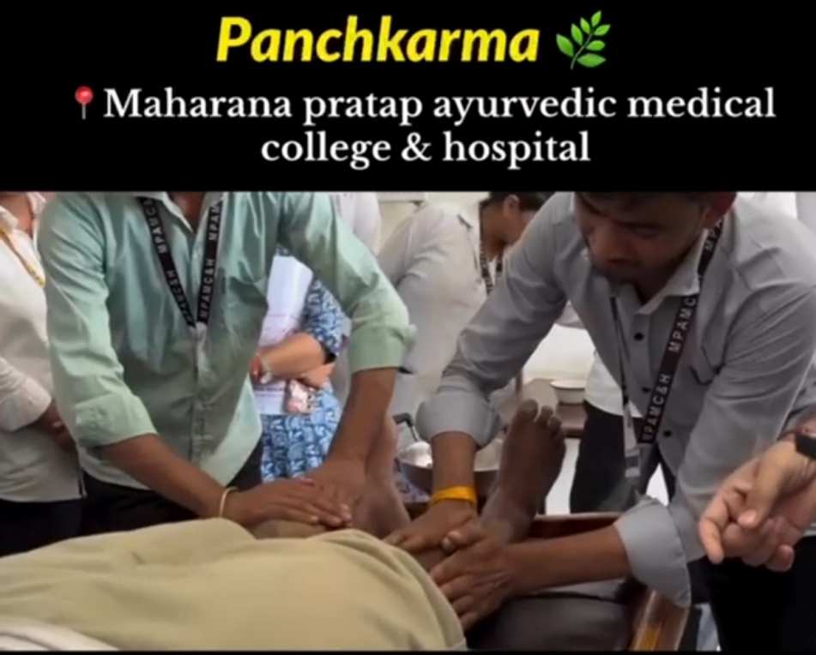
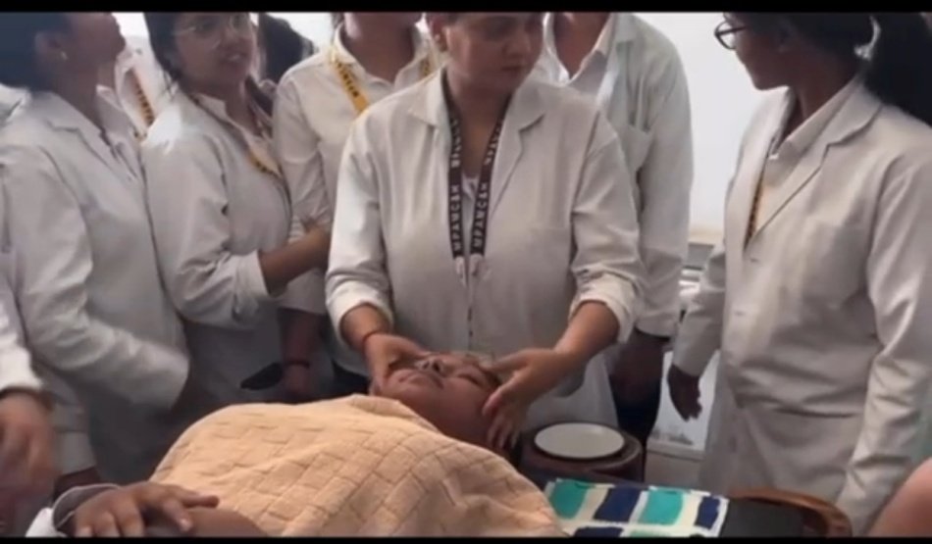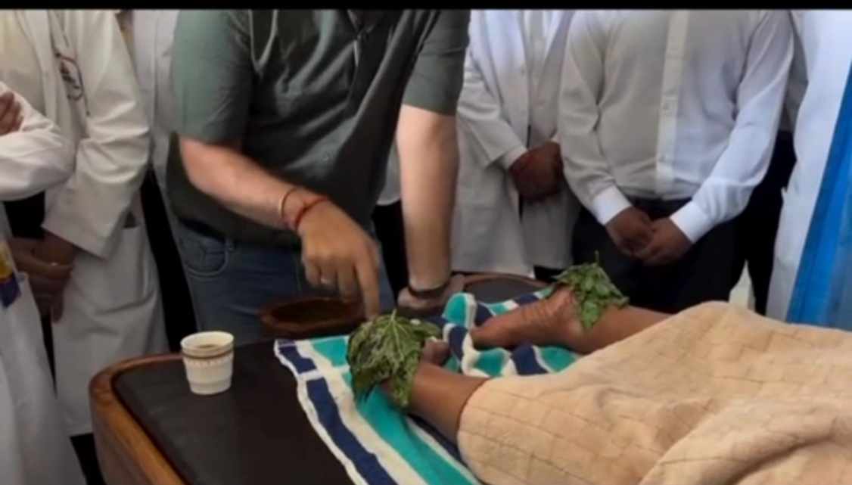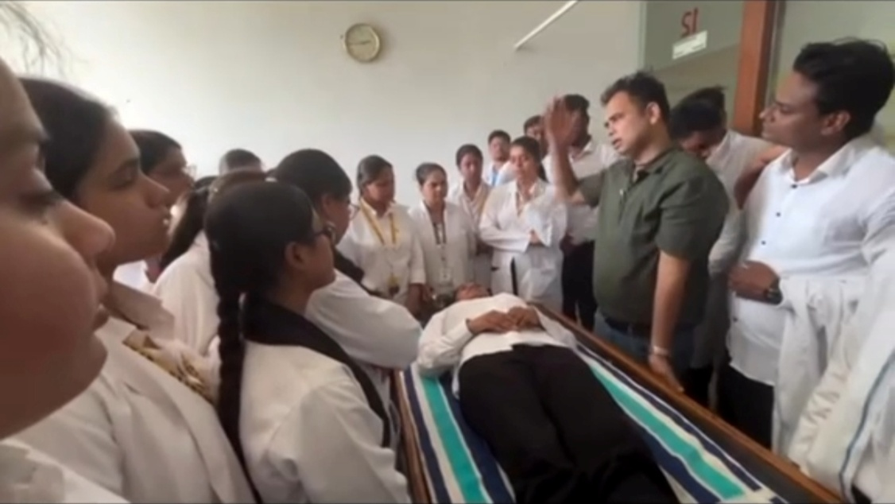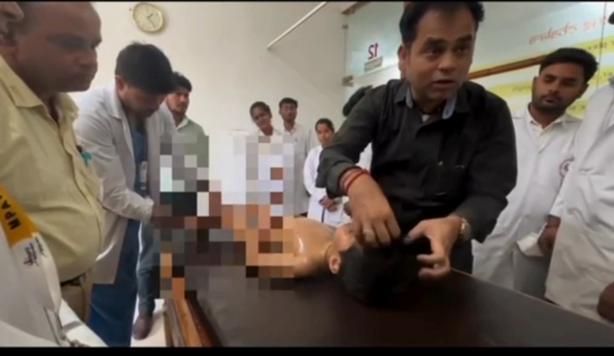

Conclusion
The refresher programme successfully provided comprehensive training in Panchakarma procedures through a structured combination of theoretical inputs, live demonstrations, and hands-on practice. It significantly contributed to improving the clinical competence of Government Ayurvedic Medical Officers.
